DNL SES Terminale : GDP and CO2 emissions
Define: GHG, decoupling, explain briefly why CO2 is changing the climate on Earth
Reading charts:
- Read the figures in 2014 (document 1).
- Explain how the figures have changed between 1950 and 2014 (document 1).
- Identify what is the situation after 2020 in the US (document 1).
- Compare with other countries in the next table (document 2)
- Prepare a presentation of about 4 to 6 minutes about the definitions above and the chart and table (document 3).
Document 1
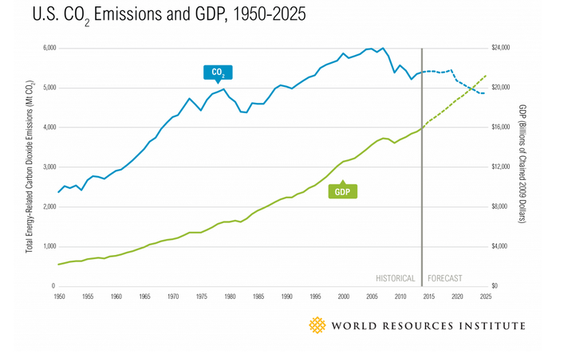
Document 2
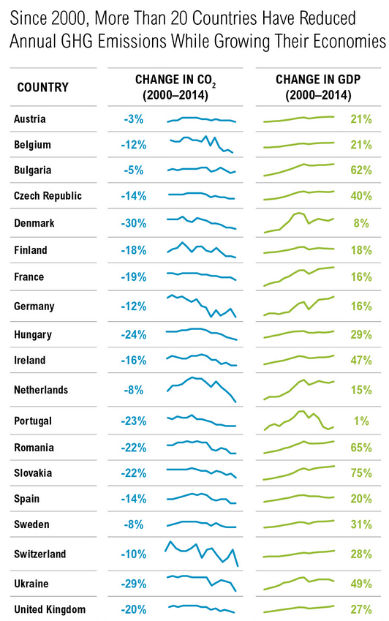
Document 3
