DNL SES 1e Sociology : the impact of socialisation

Task 1 : Definitions
- Find the definition of socialisation, norms and values
- Identify the two basic types of socialisation
- Identify the factors of socialisation
- Identify differentiated socialisation
https://www.studysmarter.co.uk/explanations/social-studies/cultural-identity/socialisation/

Task 2 : Analysis of a chart in sociology
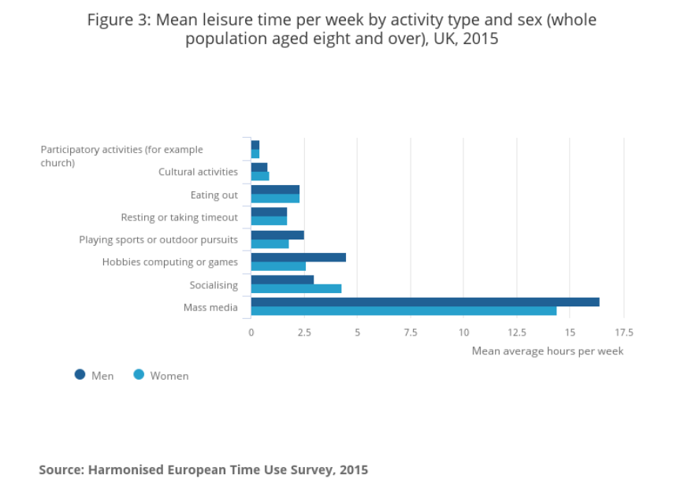
- Describe the document type quoting sources, chart type and title.
- Make sentences with the figures about Eating out, socialising and Hobbies or games.
- Explain which differentiation criteria is presented in this chart.
- Prepare an oral presentation of about 3 to 5 minutes using the tasks 1 and 2.

Task 3 : Analysis of a chart in sociology

Figure : Leisure time in hours in the UK in 2015
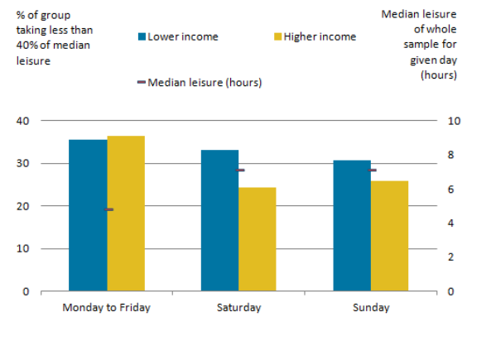
Source : ONS

- Identify the difference in leisure time according to the level of income
- Explain which differentiation criteria is presented in this chart.

