What are the sources and risks of economic growth?
FIRST ACTIVITY: DEFINITIONS
Follow this link and watch the video
https://www.investopedia.com/terms/e/economicgrowth.asp
- Define Economic growth.
- What does “GDP” stand for? How to define it?
- What is the difference between real and nominal GDP growth?
SECOND ACTIVITY: DOCUMENTS STUDY
- Read the following table: make two sentences with the growth rate of the years 2022 and 2020 (document 1).
- Choose a region and make sentences with the growth rate of GDP. (document 2).
Document 1: Annual growth of the real gross domestic product of the United States from 1990 to 2022
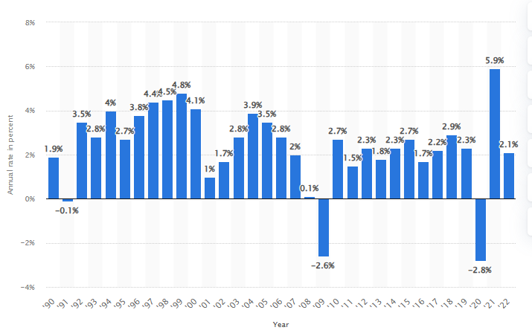
https://www.statista.com/statistics/188165/annual-gdp-growth-of-the-united-states-since-1990/
Document 2:

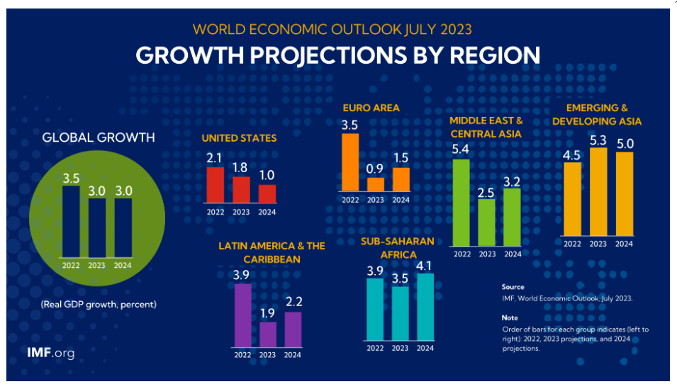
https://www.imf.org/en/Publications/WEO/Issues/2023/07/10/world-economic-outlook-update-july-2023#Overview

SOME STEP AHEAD
https://www.imf.org/en/Countries
- Look for any country of your choice and make sentences about the economic growth.
- Explain the different meanings of Economy, Economics, Economic and Economical.

