Iran Tried to Block British Tanker in Persian Gulf, U.K. Says
By David D. Kirkpatrick, July 11, 2019
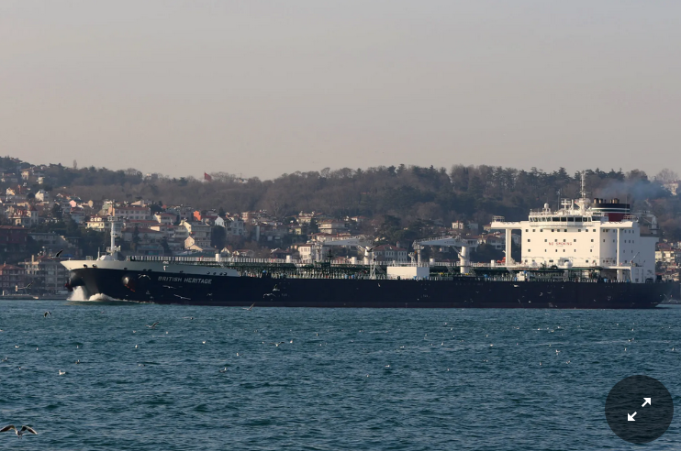
The British Heritage, a tanker, in Istanbul in March.Credit...Cengiz Tokgöz

LONDON — Three Iranian boats on Thursday briefly tried to block passage of a British tanker in the Strait of Hormuz, Britain’s Defense Ministry said, in the latest sign that Tehran is seeking any possible pressure point it can exploit in its escalating confrontation with the West.
The tanker, British Heritage, was under escort by a warship, the Montrose, and after a brief standoff but no exchange of fire the three Iranian boats complied with “verbal warnings” to retreat, the ministry said in a statement.

“We are concerned by this action and continue to urge the Iranian authorities to de-escalate the situation in the region,” it said.

The latest showdown came less than a month after the downing of an American surveillance drone by the Iranian military brought the United States to the brink of a retaliatory missile strike, aborted by President Trump only moments before launch.

Against a backdrop of building tension, many analysts and diplomats warn, each small confrontation, like the encounter with the tanker on Thursday, increases the risk of a more violent and deadly conflict.

Iran denied having attempted to stop the tanker, official news agencies reported. But as recently as last Friday, a senior Iranian military officer had warned that its forces might try to seize a ship in retaliation for the British impounding of an Iranian tanker last week off the coast of Gibraltar. The tanker was suspected of violating a European Union embargo of oil sales to Syria.

In a statement about the latest incident, BP, the oil giant that operated the ship, thanked the British Royal Navy “for its support.”
At the core of the broader confrontation with Iran is the Trump administration’s decision last year to repudiate a 2015 accord Iran reached with the United States and other international powers. The agreement called for Iran to suspend and dismantle most of its nuclear program — which the United States and its allies suspected, despite Iranian denials, might someday produce a nuclear weapon — in exchange for relief from international economic sanctions.
Demanding that Iran submit to far more sweeping restrictions on its nuclear, military and other activities, the Trump administration last year began a new campaign of “maximum pressure.” It culminated in May with the imposition of penalties designed to choke off Iranian oil exports anywhere in the world.

